Azure Self Service Password Reset.

1. From your existing Azure AD tenant, on the **Azure Portal** under **Azure Active Directory** select **Password reset**.
2. From the **Properties** page, under the option **Self Service Password Reset Enabled**, choose one of the following:
   * **None**: No one can use the SSPR functionality.
   * **Selected**: Only members of a specific Azure AD group that you choose can use the SSPR functionality. We recommend that you define a group of users and use this setting when you deploy this functionality for a proof of concept. Nesting of security groups is supported here.
   * **Azure AD Group = ADSSPwdreset**
   * **All**: All users with accounts in your Azure AD tenant can use the SSPR functionality. We recommend that you use this setting when you're ready to deploy this functionality to your entire tenant after you have completed a proof of concept.

Important

Azure Administrator accounts will always have the ability to reset their passwords no matter what this option is set to.

1. From the **Authentication methods** page, choose the following:
   * **Number of methods required to reset**: We support a minimum of one or a maximum of two.
   * **Methods available to users**: We need at least one, but it never hurts to have an extra choice available.
     + **Email**: Sends an email with a code to the user's configured authentication email address.
     + **Mobile phone**: Gives the user the choice to receive a call or text with a code to their configured mobile phone number.
     + **Office phone**: Calls the user with a code to their configured office phone number.
     + **Security questions**: Requires you to choose:
       - **Number of questions required to register**: The minimum for successful registration. A user can choose to answer more questions to create a pool of questions to pull from. This option can be set to three to five questions and must be greater than or equal to the number of questions required to reset their password. The user can add custom questions if they select the **Custom** button when they select their security questions.
       - **Number of questions required to reset**: Can be set from three to five questions to be answered correctly before you allow a user's password to be reset or unlocked.

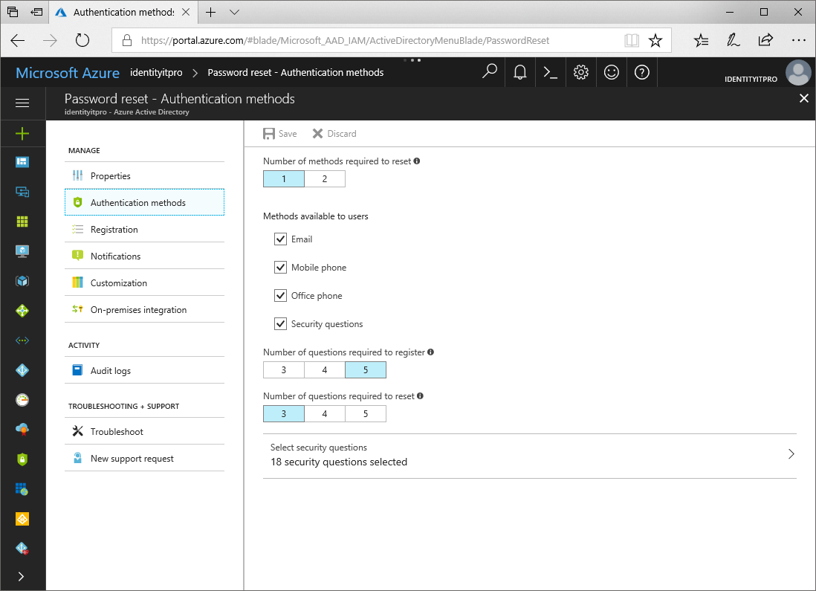

1. Recommended: Under **Customization**, you can change the **Contact your administrator** link to point to a page or email address you define. We recommend that you set this link to something like an email address or website that your users already use for support questions.
2. Optional: The **Registration** page provides administrators with the option to:
   * Require users to register when they sign in.
   * Set the number of days before users are asked to reconfirm their authentication information.
3. Optional: The **Notifications** page provides administrators with the option to:
   * Notify users on password resets.
   * Notify all admins when other admins reset their password.

At this point, you have configured SSPR for your Azure AD tenant. Your users can now use the instructions found in the articles [Register for self-service password reset](https://docs.microsoft.com/en-us/azure/active-directory/active-directory-passwords-reset-register) and [Reset or change your password](https://docs.microsoft.com/en-us/azure/active-directory/active-directory-passwords-update-your-own-password) to update their password without administrator intervention.

Tip

Test SSPR with a user rather than an administrator, because Microsoft enforces strong authentication requirements for Azure administrator accounts. For more information regarding the administrator password policy, see our [password policy](https://docs.microsoft.com/en-us/azure/active-directory/authentication/concept-sspr-policy#administrator-password-policy-differences) article.

# [password reset registration page](https://aka.ms/ssprsetup).

\*\*\*\*\*\*\*\*\*\*\*This is where you enter your phone number and security questions. Should already be done.\*\*\*\*\*\*\*\*\*\*

<https://account.activedirectory.windowsazure.com/PasswordReset/Register.aspx?regref=ssprsetup>

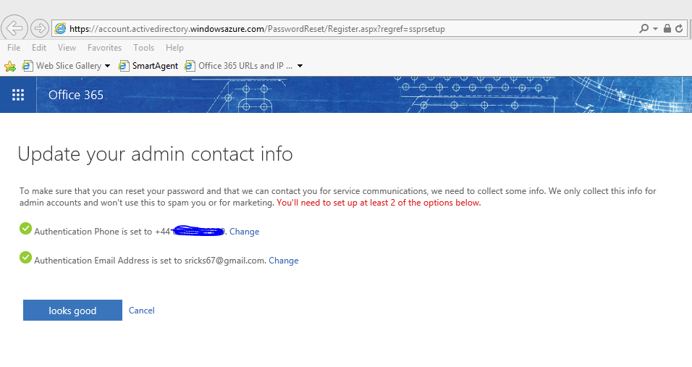

# [self-service password reset tool](https://go.microsoft.com/fwlink/p/?LinkId=522677" \t "_blank)

<https://passwordreset.microsoftonline.com/>

You can get to this on your phone. You can unlock your account or change your password.

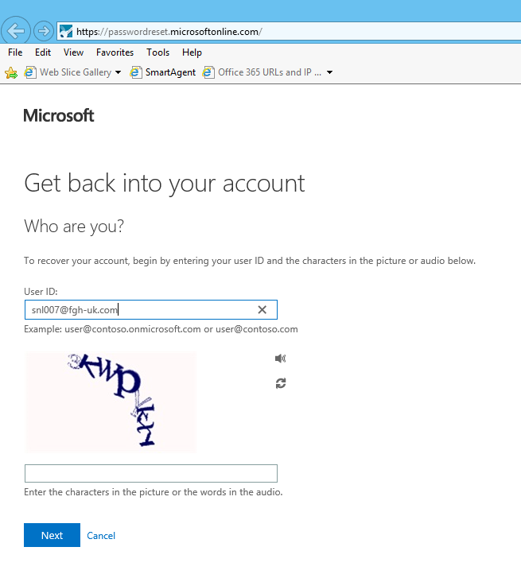

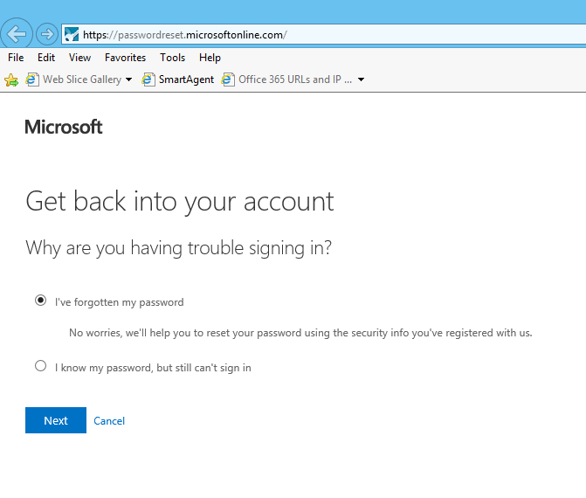

Or…..

